**The Superior University**



**Programing for Artificial Intelligence**

**Lab Task**

**Name:** Zeeshan Haider

**Roll No**: 065

**Section**: 4B

**Submitted to:** Sir Rasihk

**Water Jug**

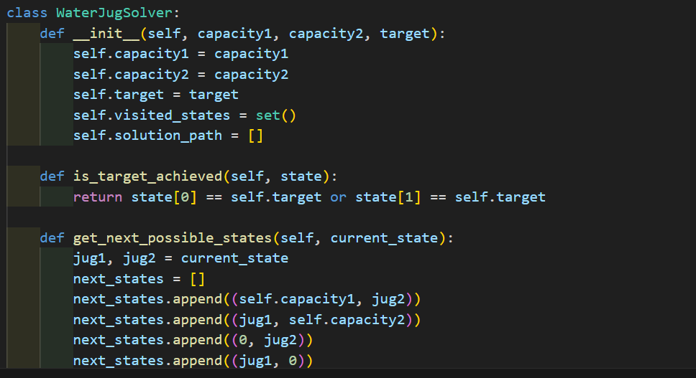

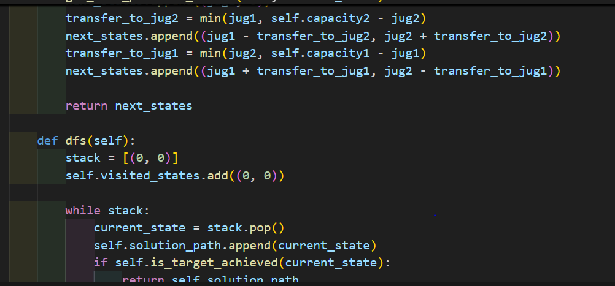

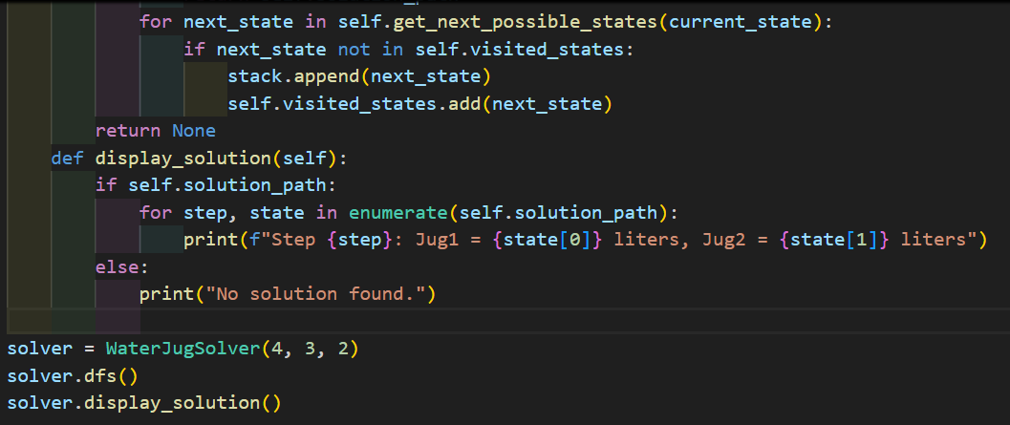

**Output:**

